|  |  |
| --- | --- |
| **Prepared by** | Phan Zi Jian (Intern 2020) |
| **Date** | 25 September 2020 |

**Credit Policy Deviation (CPD) SOP**

**Background:**

The CPD files are store at:

*Z:\BB RISK\Policy Exceptional and Credit Policy Deviations\2.CPD\mmyy*

The name of the file is

*Policy_Breach_Monthly_mmyy.xls.*

* Create a template by save as the previous file. MM refers to Month and yy refers to Year.

Every 3rd of each month, an email will receive from Abdul Rahman IT from EOS department, which attached data source for EC: *Policy Breach Monthly*, *EC Comment Only Monthly Final* and *AA Approved Monthly*.

1. **Policy Breach Monthly,**
   1. Store at: *BB RISK\New House\CRD\2020\08. Aug 2020\raro\PB*.
   2. Use Pivot to summarize the data
   3. Select GCIF, BRWR Lending Unit, Entity, AA no, OIC (US_USER_NAME), Final Approver Level, BRR, FRR, Approval Date, Policy Breach, Rational, Statement Date and Account Type to put in the row box in pivot sheet:

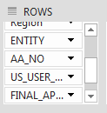

**Remember to filter CPD 1,2,3,4,5,6,7,8 and others under Policy Breach Column.** Please refer to**Tips ad tutorial while using Pivot.docx**and you should be able to obtain a table looks like below:

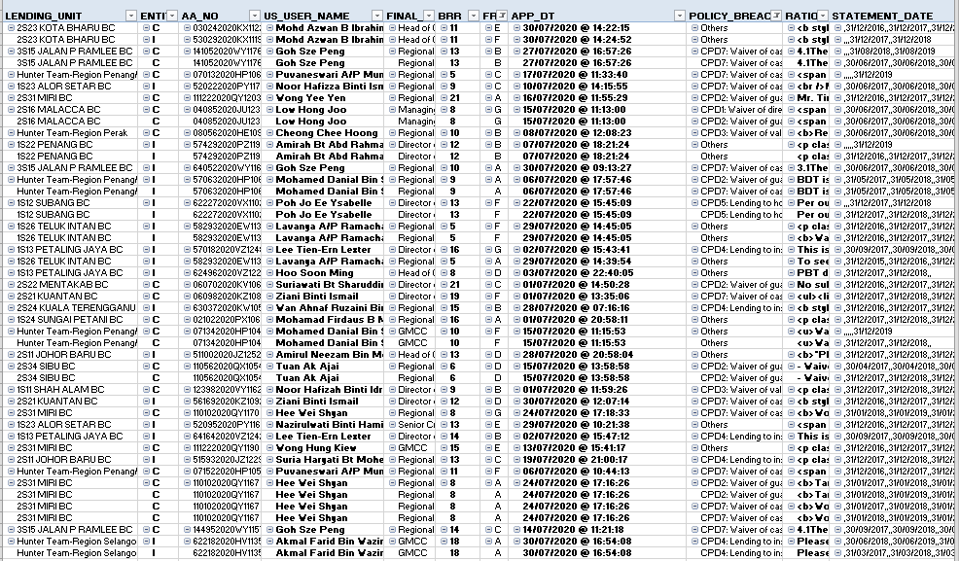

Paste it to the template

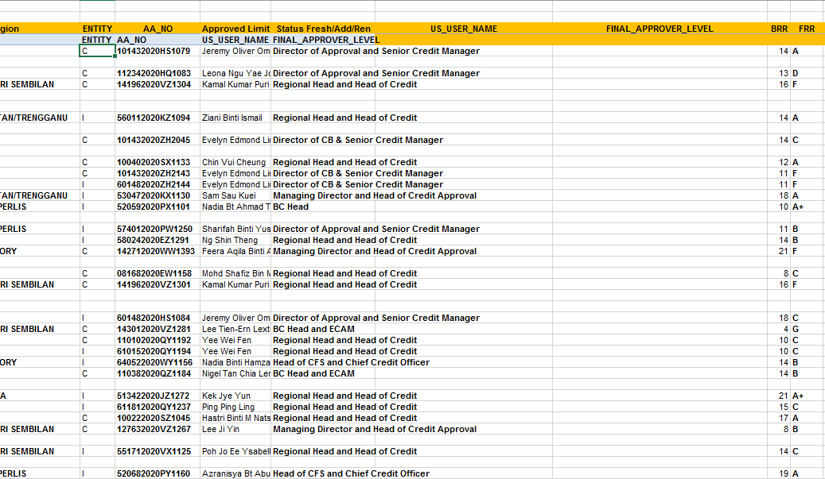

Rearranged the data according to the heading of template

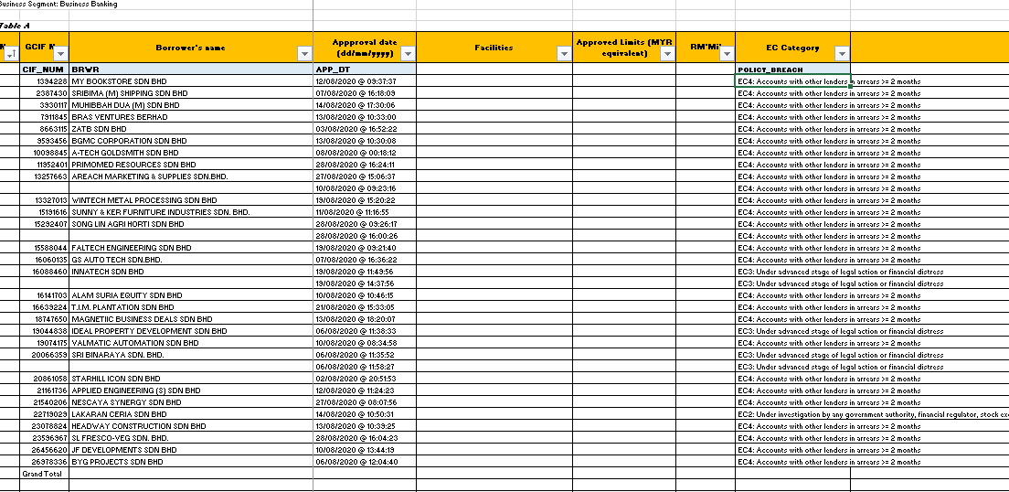

# As you can observe, some of the cells are blank. This is because it is same borrower and GCIF. You may CTRL+ left Click this Tips ad tutorial while using Pivot.docx and view the How to fill in the blank cell resulted by repeated label to seek for method to solve the problem.

It should look like below after applied the method.

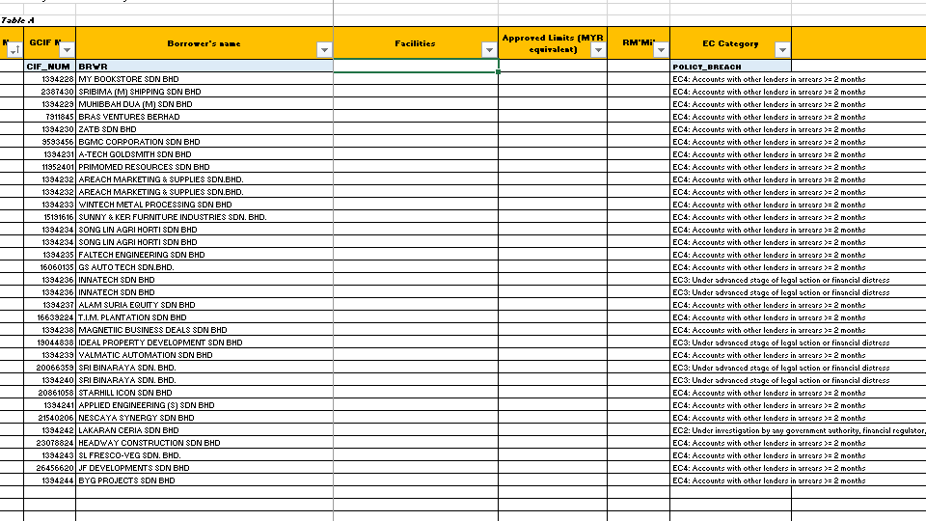

Finally, removed the heading row from Pivot:

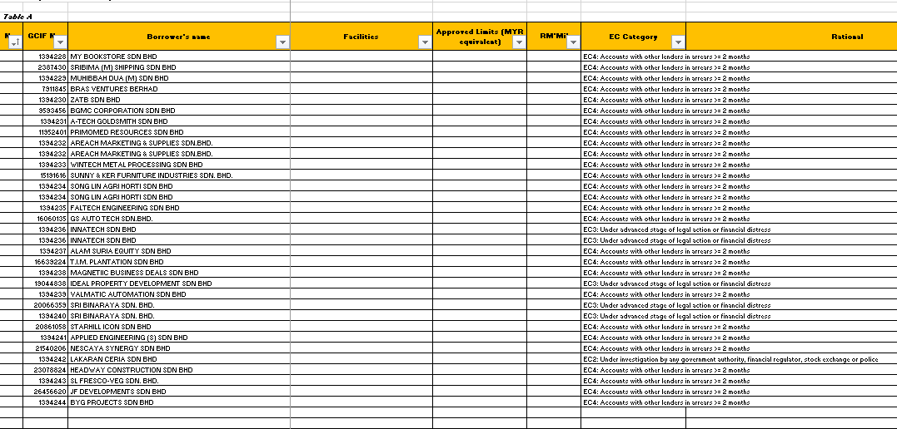

It should look like pic above.

You may found that the column of Nature of Application(Status Fresh/Add/Renew), Approved limit and RM Mil are empty.

You can get these data from: *BB RISK\New House\CRD\2020\08. Aug 2020\raro\PB* *ADH201700589 AA Approved Monthly*

1. **AA Approved Monthly** In this file, you can obtain 3 column info: Status Fresh/Add/Renew, Approve limit and RM Mil

2.1 You can get Status Fresh/Add/Renew approve limit by mapping it with vlookup.

You may CTRL+ Left Click Link: Excel Functions Dictionary.docx for more detail

The formula in this case is:

=vlookup (AA number cell in **template**, Range from “First AA Number column” to “Nature of Application column” in **AA Approved Monthly”**, The number of column between AA number column and Nature of Application column”, 0)

2.2 For the approve limit, pivot the data in AA Approved limit. Put AA Number in column box and approve limit in value box. This is to sum out of approve limit for each AA Number. Then in RM Mil, divide the approve limit by formula = approve limit/ 1000000.

1. **EC Comment Only Monthly Final (This is to map the Rational Coloumn)**

The data is store at *BB RISK\New House\CRD\2020\08. Aug 2020\raro\PB* *EC Comment Only Monthly Final*

Pivot to summarize the data. In the Column Box put “AA number” and “Rationale”. By using vlookup, map the rationale to the template by using AA number.

You may refer to Excel Functions Dictionary.docx by CTRL+ Left Click the link for more detail

The formula in this case is:

=vlookup (AA number cell in **template**, Range from “First AA number cell” to “last rationale cell” in **EC Comment Only Monthly Final**, The number of column between AA number column and Rationale column”, 0)

Remember **to use F4 to lock** the Range from “First AA number cell” to “last rationale cell” in AA Approved Monthly”

You may refer to Z:\BB RISK\Policy Execptional and Credit Policy Deviations\2. CPD\Aug 20\Policy_Breach_Monthly_Aug2020 (Mag Checking)2.xlsx as a reference to a completed task.

Additional Field to map

*To map the Region manually from file: *BB RISK\Code\BC & Region EOS*

*To map the Account Status(PL,WL, SMA, EWS,GIL) for the month from file:

a) PL from file Master BB Funded Non Funded. File: *BB RISK\Master BB\Master BB 2021\Master BB Funded Non Funded*

b) SMA WL EWS from file: *BB RISK\Master BB\Master BB 2021\Month\TF02(Task Force)*

c) GIL from file *BB RISK\Master BB\Master BB 2021\Month\GIL by BC*

h) CPD Y/N - Blank

i) Comments – Blank

j) Learning Points - Blank

j) Status (Map the latest status for Status PL/SMA/WL/EWS, GIL) – This is for the previous borrowers to know the latest status from Master Listing)

After the table is completed, you may start the massaging:

1. **Massaging:**
2. Always remember to exclude account that fulfil criteria mentioned in the exemption list **before removing duplicate borrowers.**
3. Refer to policy to exclude account that fulfil exemption criteria.(for manual checking)
4. For the removed borrower, keep it as backup.

Eg: CPD 4 can be excluded if subordination able to cover negative net worth. 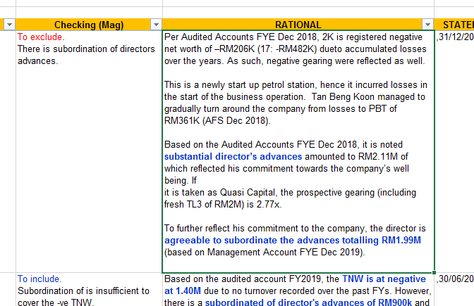

** (Please refer to BB RISK\Email blast to BCs\Exceptional Credits\ Exceptional Credits Credit Policy Deviations for more detail about exceptional criteria.)

1. When BRWR and Policy Breach are the same with previous period
2. Removed latest “BRWR” and “CPD”, but replace previous “BRWR’s approved limit” with latest one.
   * + Eg. Ali Sdn Bhd breached CPD 1 in Jan 20, with approved limit RM 1 mil. In May 20, Ali Sdn Bhd breached CPD 1 again but approved limit is RM 2 mil. Than removed Ali Sdn Bhd in May 20 and change approved limit at Jan 20 to RM 2 mil.

Eg.

|  |  |  |  |  |
| --- | --- | --- | --- | --- |
| **No** | **BRWR** | **Month** | **App Limit** | **CPD - Adj** |
| 1 | **Ali Sdn Bhd** | **Jan 20** | ~~1,000,000.00~~ | **CPD 1** |
| ~~2~~ | ~~AIi Sdn Bhd.~~ | ~~May 20~~ | **2,000,000.00** | ~~CPD 1~~ |

***Remove the entire No 2 account, but replace App Limit of Sep 19 (8.23 Mil) with RM 7.53 Mil from Apr 20.

Total Borr =1, Total CPD =1

1. When BRWR repeat only, but Policy Breach are not the same with previous period.
   1. Keep the borrower in the list, but do remember to prevent double count of borrowers when counting ratio.
      * Eg. In Jan 20, Ali Sdn Bhd breached CPD 1. In May 20, Ali Sdn Bhd breached CPD2. Keep both account, but removed 1 borrowers when calculating the CPD ratio.

Eg.

|  |  |  |  |  |
| --- | --- | --- | --- | --- |
| **No** | **BRWR** | **Month** | **App Limit** | **CPD - Adj** |
| 1 | Ali Sdn Bhd | Jan 20 | 1,000,000.00 | CPD 1 |
| 2 | AIi Sdn Bhd. | May 20 | 2,000,000.00 | CPD 2 |

***Keep both account, but remove 1 borrowers count when counting total number of borrowers.

Total Borr = 1, Total CPD =2

**\*Method to Calculate Approve Limit**

Sometimes some borrowers have more than 1 CPD. While calculating the A/L, we should only count it once. This is because they are the same account and facilities, so the improvement limit are the same and should not be calculate twice.

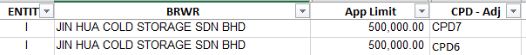

* So Copy and paste the whole table in another worksheet.
* For those borrowers have more than 1 CPD, remove one of the account.
* If the entity is Islamic and Conventional, remove one of the account but sum up the A/L. Islamic and Conventional have different facilities, so the approve limit should be sum up in this scenario.

|  |  |  |  |  |  |
| --- | --- | --- | --- | --- | --- |
| **No** | **BRWR** | **Month** | **App Limit** | **CPD - Adj** | **Entity** |
| 1 | **Ali Sdn Bhd** | **Jan 20** | ~~1M~~3M | **CPD 1** | **C / I** |
| ~~2~~ | ~~AIi Sdn Bhd.~~ | ~~May 20~~ | ~~2M~~ | ~~CPD 2~~ | ~~C~~ |

* Then pivot to ensure all borrower has one CPD only. Compare the number of borrower with the pivot of main table. It means that all your steps are correct if the number of borrower are the same. You may refer to the “How to count number of column” in Tips ad tutorial while using Pivot.docx to view how to count number of borrowers.
* Please be noted that the only purpose for this table is to calculate Approve Limit only, you should refer to the main table for other purposes.

1. **Ratio Calculation**

|  |  |  |  |  |  |  |  |  |  |  |  |  |
| --- | --- | --- | --- | --- | --- | --- | --- | --- | --- | --- | --- | --- |
|  | |  |  |  |  |  |  | |  |  |  | |
|  |  |  |  |  |  |  |  | |  |  |  | |
| |  | | --- | |  | |  |  |  |  |  |  |  | |  |  |  | |
|  |  |  |  |  |  |  |  | |  |  |  | |
| cid:image005.png@01D4E942.E1F01CF0 |  |  |  |  |  |  |  | |  |  |  | |
|  | | | | | | | |
| Example for :  **Calculation Ratio for CPD Borrowers:**    Total No. of CPD Borrowers/Total No. of Borrowers In BB Segment  = 555/7664  = 7.24%  **Calculation Ratio for Approved Limit**  Total CPD Approved Limit/Total BB Approved Limit  =  5,698,649,853.20 / 43,873,084,245.39  = 12.99%  ***Sharedfolder filestor BB RISK\BB DATA\2020\8. Aug 2020***  Approved Limit from Susen’s Data(OD, OD Credit Balance), Daniel (TL,Trade & STRC). The data per  sharedfolder filestore as above. | | | | | | | |  | | | |  |
| 1. ODTL FY1112 SMF Product Table 2. ODCr Bal 1011 Product Table 3. 2020-08 Trade Emplacement Authorized Limit 2020 4. 2020-08 BB TL (for Yan May) 5. USD TL | | | | | | | |